|  |  |  |  |  |  |  |
| --- | --- | --- | --- | --- | --- | --- |
| **J17. Montserrat CF – 1 Tran. Casanova - 0** | | | | 26gen2019 - Mun. Montserrat 16:00 | | |
| **Dem** | **Jugadors** | **Substitucions** | **Minuts** | **Gols** | **Assis** | **Targetes** |
| PT | Andrés |  |  |  |  |  |
| Lat | Laguna | Cata | m.80 |  |  | 1 |
| Cen | Gomera | Pecero | m.60 |  |  |  |
| Cen | Charlie |  |  |  |  |  |
| Lat | Jorge |  |  |  |  |  |
| Mig | Cardona |  |  |  |  |  |
| Mig | Juanvi |  |  |  |  | 1 |
| Ext | Torte | Tramvia | m. 75 |  |  |  |
| Ext | Fenoll | Manyano | m. 60 |  |  |  |
| Mig | Penella | Gabi | m. 45 |  |  |  |
| Dv | Rai | Julio | m. 45 |  |  |  |
| Dv | Manyano |  |  |  |  |  |
| At | Gabi |  |  | 1 |  |  |
| Ext | Julio |  |  |  |  |  |
| At | Tramvia |  |  |  |  |  |
| Lat | Pecero |  |  |  |  |  |
| Lat | Català |  |  |  |  |  |

**Gols**:

**1 – 0: m.80.** Gabi a la treta d’un córner.

**Resultats**

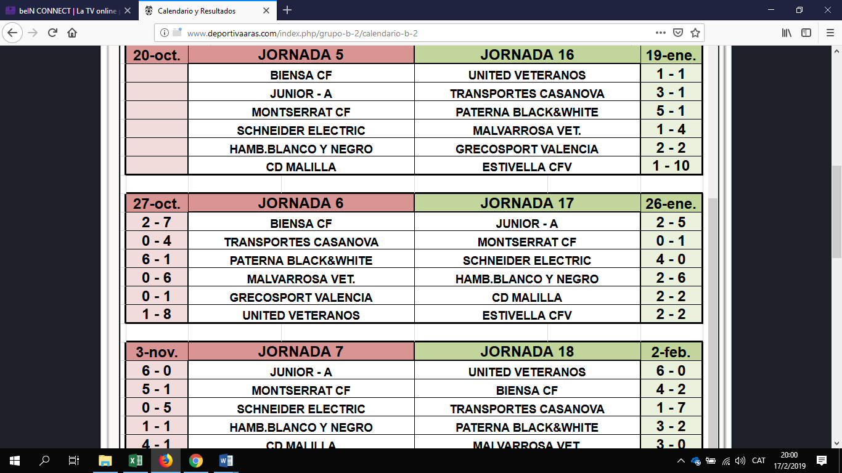

**Classificació**

